Estimation of Business Expenses

1. INTRODUTION
   1. Overview

This report delves into the fascinating realm of business expenses and provides a visual exploration of the various expenditures incurred by different businesses. It showcases the distribution of expenses, identifies key cost drivers, and highlights areas of potential optimization or concern. The visual representations allow for intuitive analysis, facilitating a deeper understanding of expenditure patterns and their implications for business performance. Decision –makers, financial analysts, and stakeholders can gain valuable insights into the financial health of businesses, identify areas of inefficiency or opportunity, and make informed decision to optimize resources and drive growth.

* 1. Purpose

The data analyze of using tableau software in estimation of business expense to get a deeper understanding of how their money is being spent and they can optimize their resource more effectively

1. PROBLEM DEFINITION & DESIGN THINKING

2.1. Empathy Map

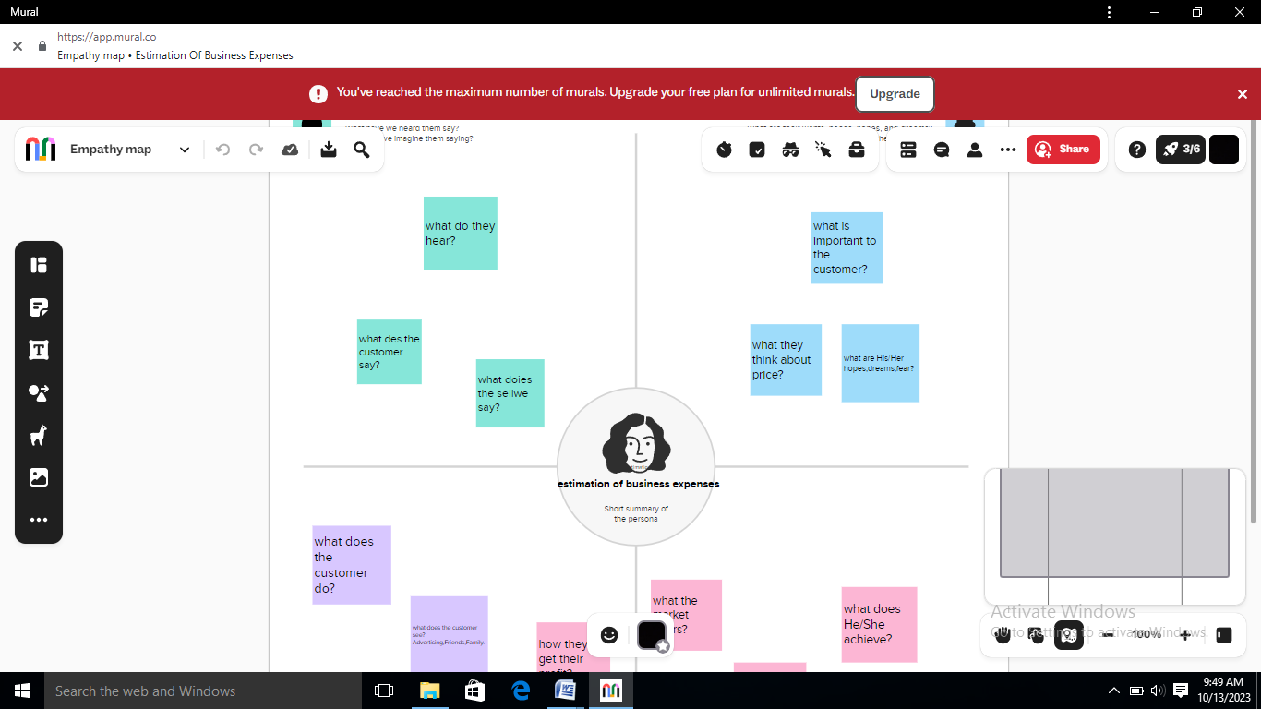

2.2 Ideation & Brainstorming Map

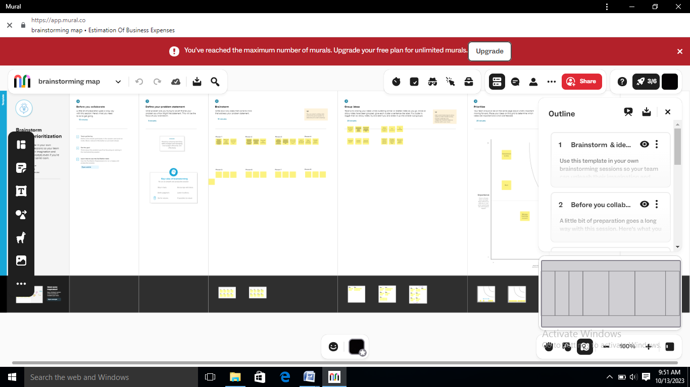

RESULT

3.1. Annual PayRoll

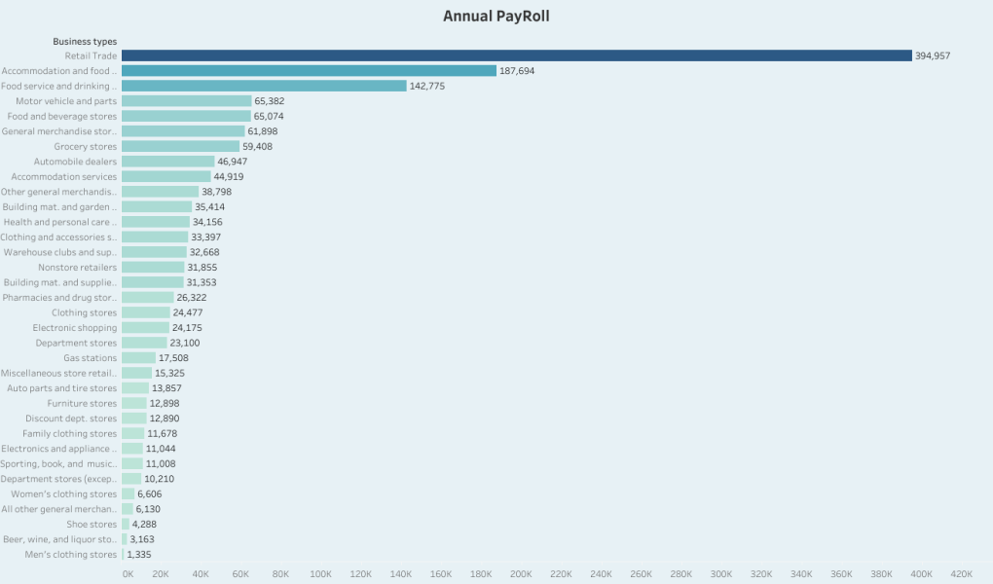

This line chartshows the Annual Payroll in Estimation of Business Expenses. From this we have observed maximum (187,694) Retail trade and minimum (1,335) of Men’s clothing store.

3.2. Advertisement Cost

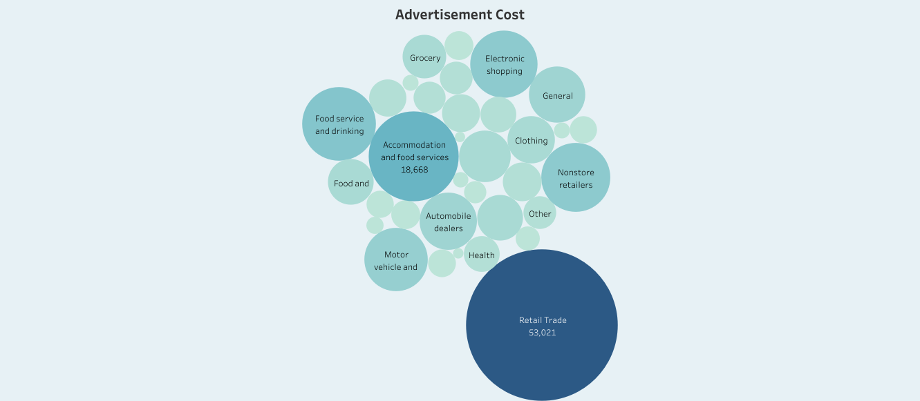

This scattered chart shows the cost of advertising business. This shows the high cost used in retail trade and low cost used in health.

3.3. Contract labor VS Employee

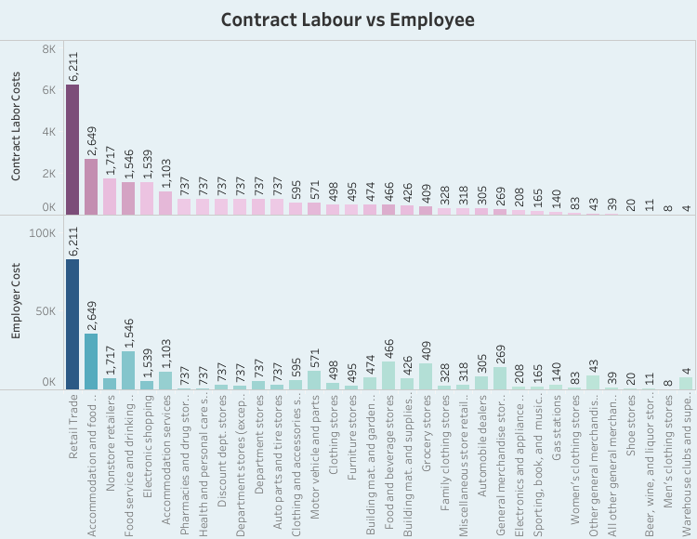

This bar graph explains the relation between the contract labor cost and employer cost. This shows the same amount is spent both contract labor and employee

3.4. Employee (Insurance VS Pension)

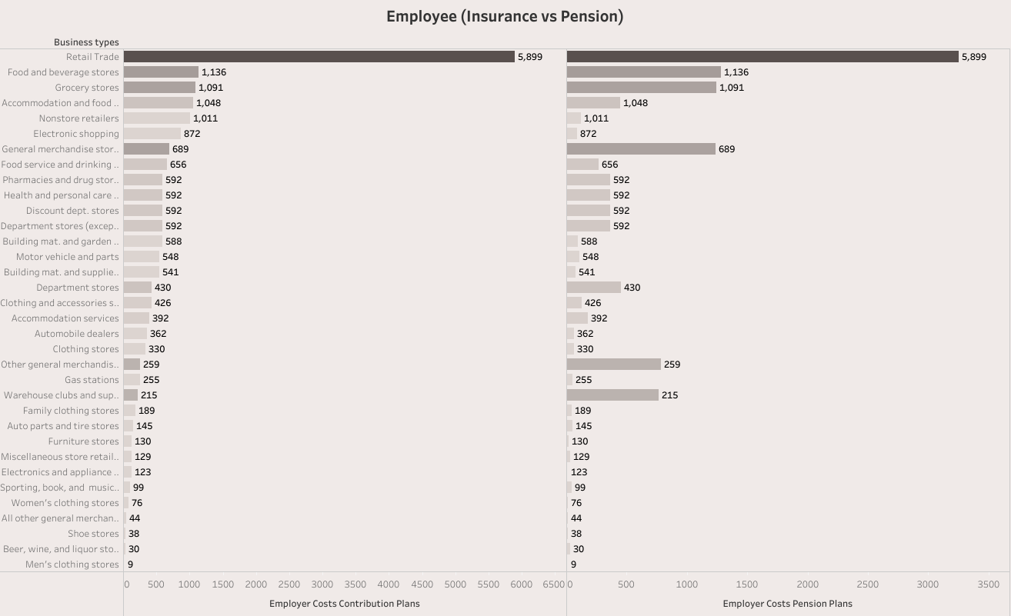

This graph is between employees insurance and pension. The maximum amount is spent in retail trade and minimum amount is spent in men’s clothing stores.

3.5. Equipment costs

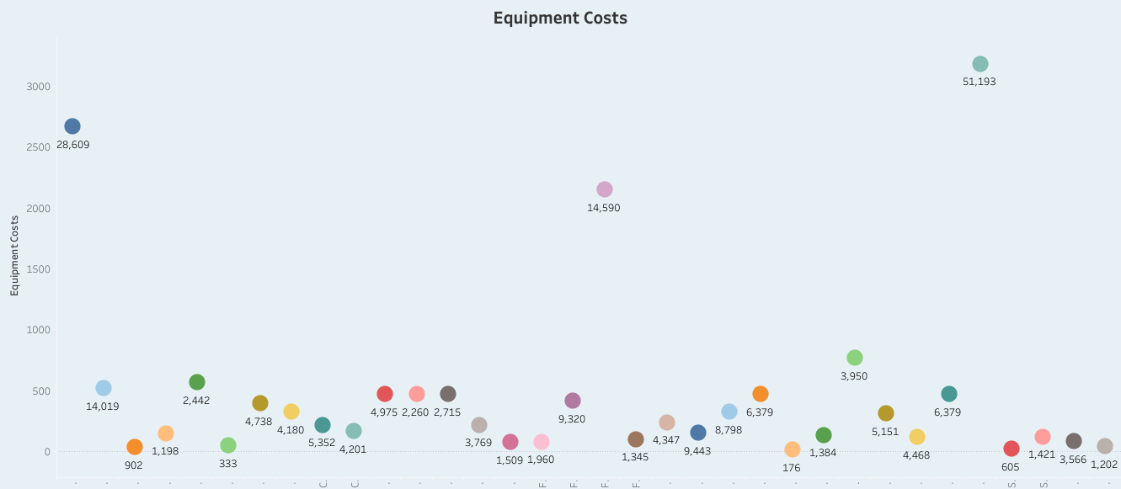

This graph shows the amount spent for equipments. Larger amount spent retail trade (51,193) and lower amount spent in men’s clothing stores (12) and shoe stores (21).

3.6. Expenses YOY

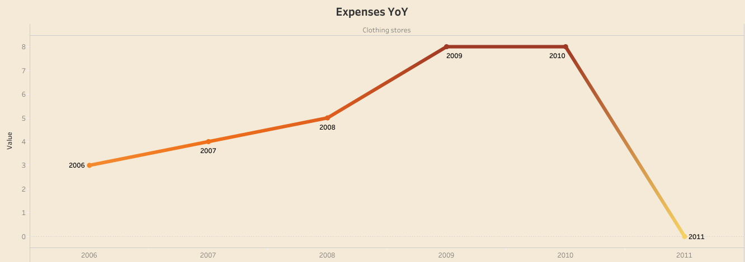

Expense YOY means Year-Over-Year growth. This line graph shows the growth of business between the years 2006-11. The business highly grow in 2009&10 and falls in 2011.

3.7. Fuel

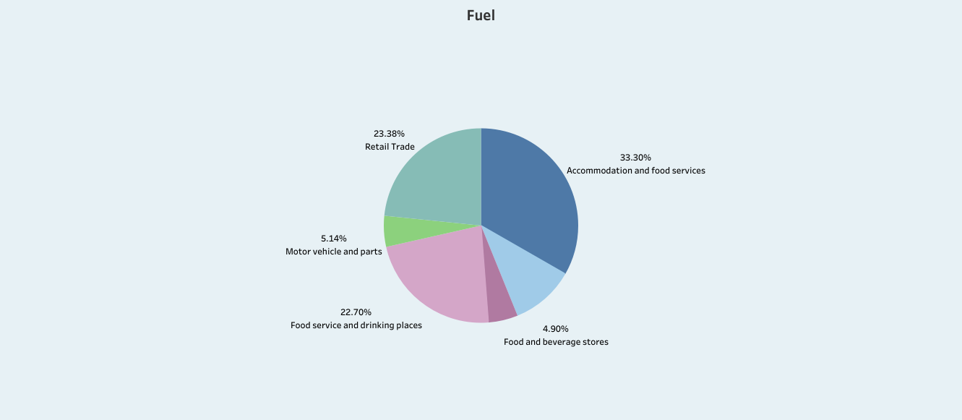

Thus pie chart shows the fuels used for the business. Maximum amount of fuel is used for accommodation and food services (33.30) and minimum amount used for beverage stores (4.90).

3.8. Maintenance of buildings

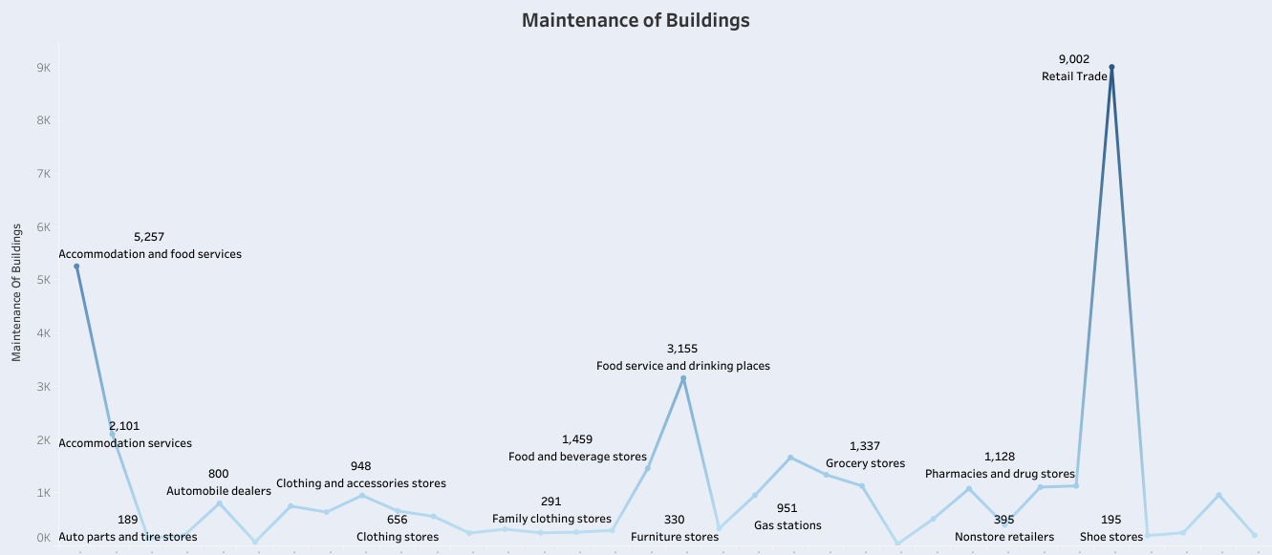

This line graph explains the amount spent for maintain buildings. High cost used in retail trades (9,002) and low cost used for auto parts and tire stores (189).

3.9. Power expenditure

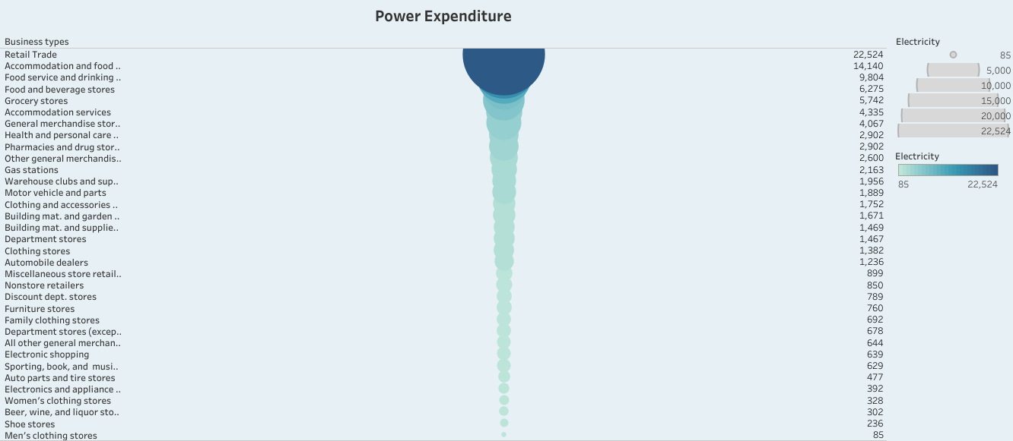

This graph shows the power expenditure used in business. Maximum expenditure is retail trade and low expenditure is men’s clothing stores

3.10. Rental payment machinery

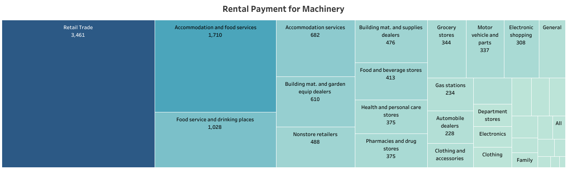

This table explains the rent paid for machineries. Maximum rent is paid for retail trade(3,461) and minimum rent paid for automobile dealers.

3.11. Taxes & Licenses

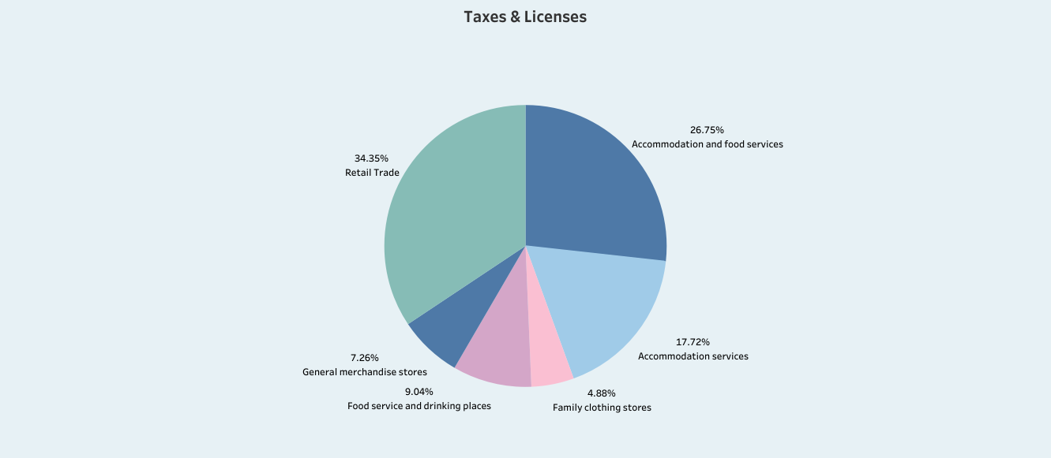

This pie chart shows the taxes paid for business. The maximum tax paid is retail trade (34.35%) and minimum amount of tax paid is for family clothing stores (4.89%).

3.12. Transportation

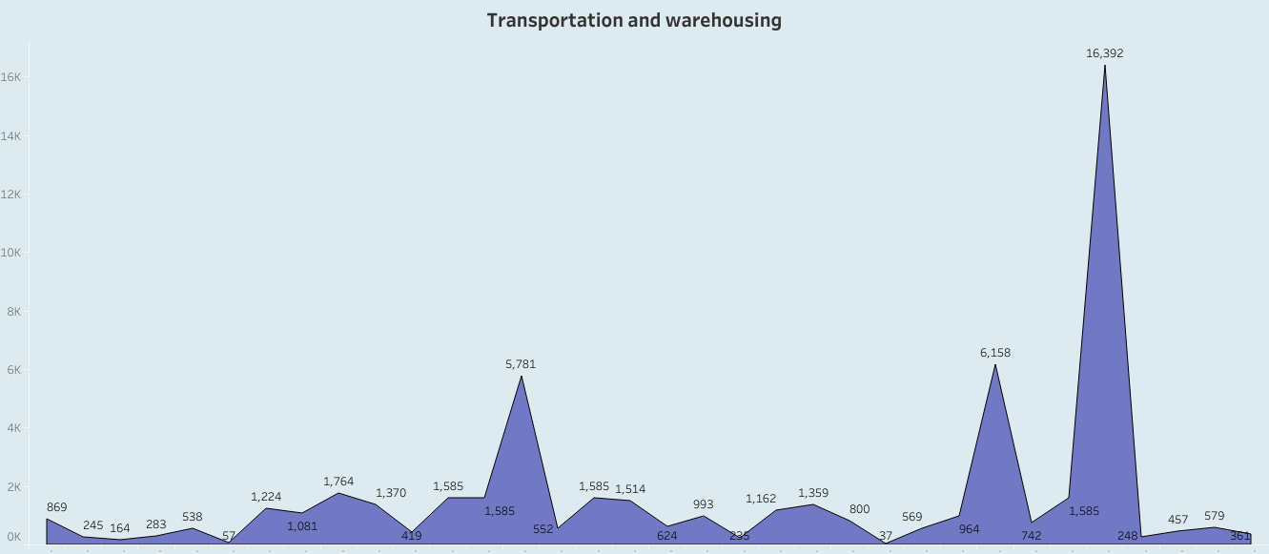

This line graph shows the amount spent for transportation. High amount is spent for retail trade and low amount is spent for beer and wine.

3.1.Business expense.Dashboard 1

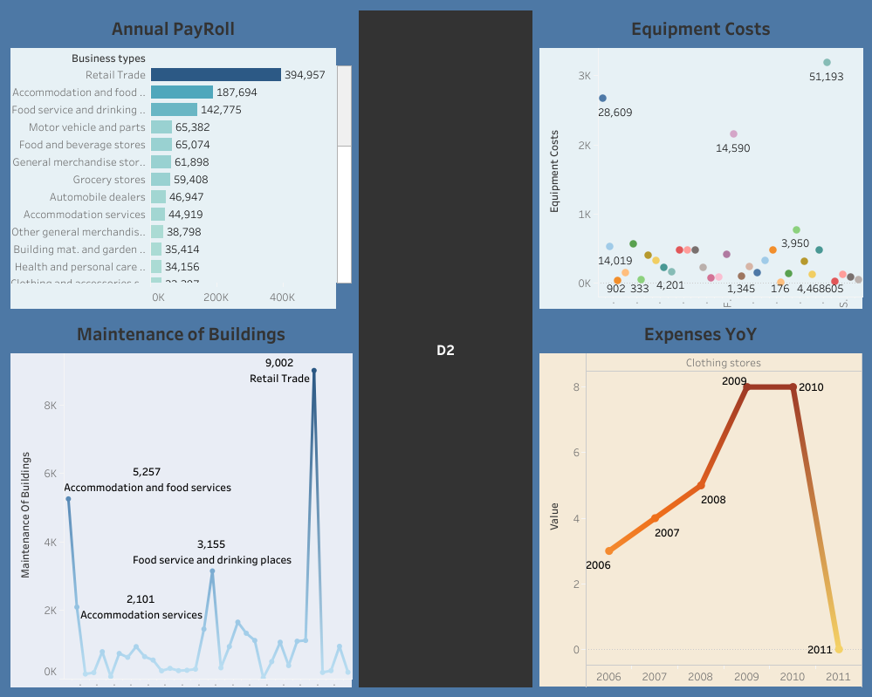

In this dash board we arrange four sheets which explains the Annual Payroll, Equipment Costs, Maintenance of building and Expenses YOY.

3.2.Business expenseDashboard -2

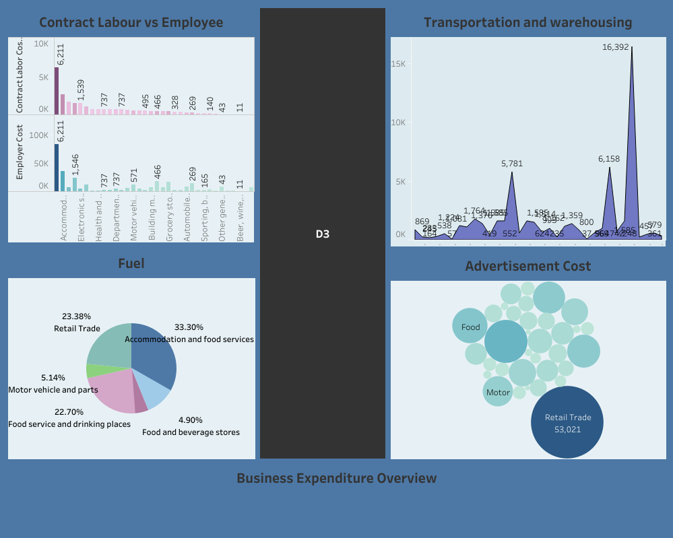

In this dashboard we arrange four sheets which explains about Contra labor and Employee, Transportation, Fuel and Advertisement Cost spent for business.

3.3 Business expense dashboard-3

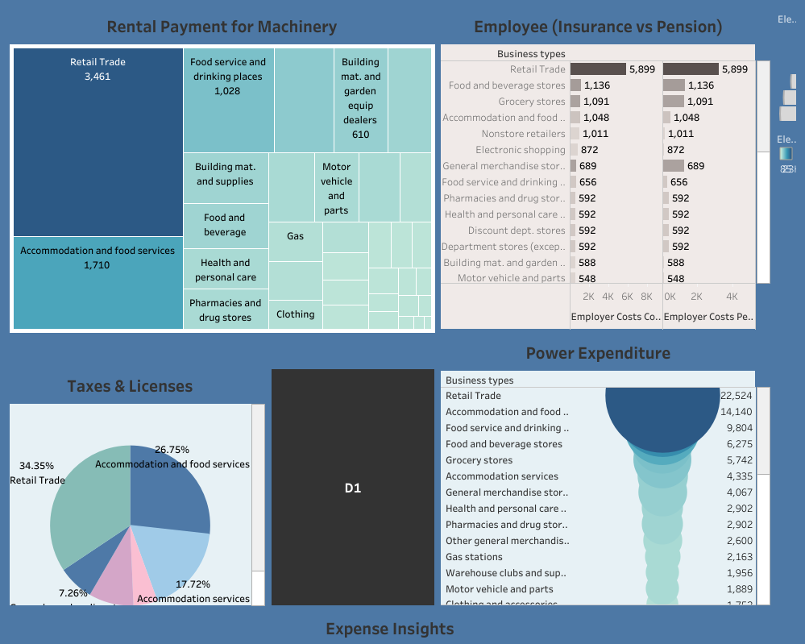

3.4. Story of Business expense



4. ADVANTAGES & DISADVANTAGES

ADVANTAGE:

Data analytics in business helps an organization make better decisions and also increase the efficiency of work. The analytics keeps you updated. Personalization of products and services. Improving quality of products and services.

DISADVANTAGE:

Lack of alignment within team and lack of commitments and patience are the main disadvantage in business. Low quality of data is complicated to analyze. And privacy concerns.

5. APPLICATION S:

Data analysis can be applied in business in various ways. It can be applied to analyze customer behavior, optimize marketing campaigns, improve supply, enhance product development, identify fraud. And improve overall business.

6. CONCLUSION:

In this project work we have created visualizationof different field from the dataset of business expense using Tableau desktopsoftware. After the visualization dashboard and story are created and publish Tableau public online account. From the dashboard and story we have conclude that expense depend upon the type business, working employees and equipment used in particular business.

7. FUTURE SCOPE:

* To create visualization betweenbusiness expense vs state
* To create visualization business expense Vs different year
* To analyze business expense VS employee qualification or skill